SYMANTEC ENDPOINT PROTECTION INSTALLATION GUIDE
- Before start the Installation, please make sure you already Uninstall old antivirus.
- Login UTM Hotspot with your ID.
- Open the Web Browser and type antivirus.utm.my at Address Bar.
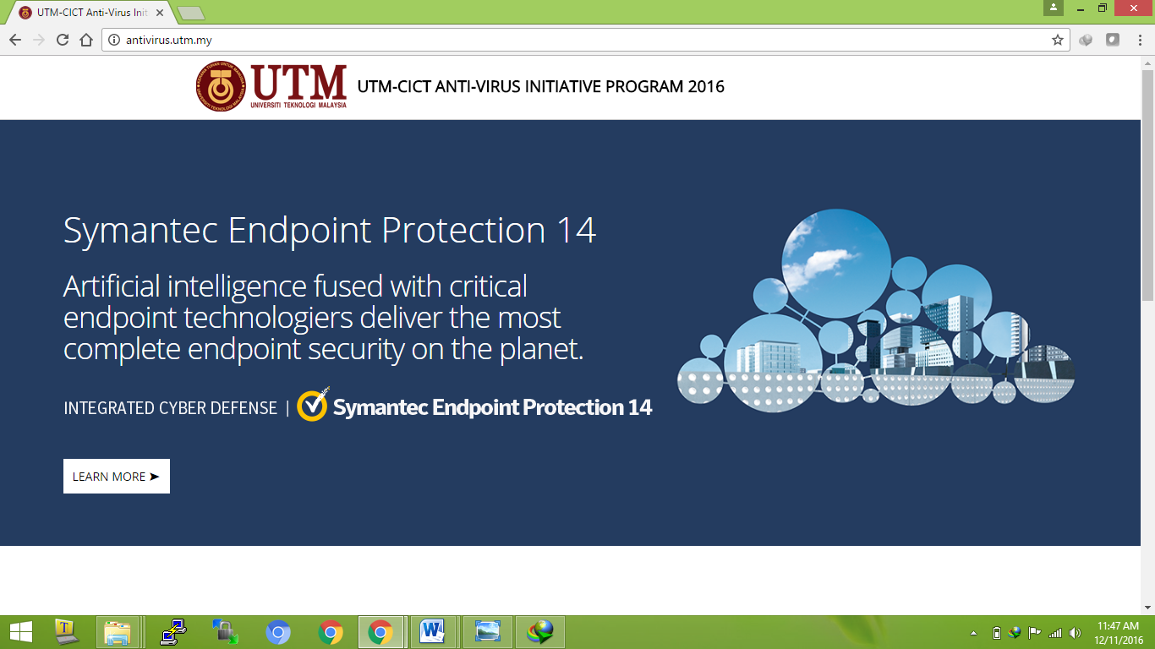
- Scroll down and Download the antivirus software with your compatible OS (32bit, 64bit or Mac)
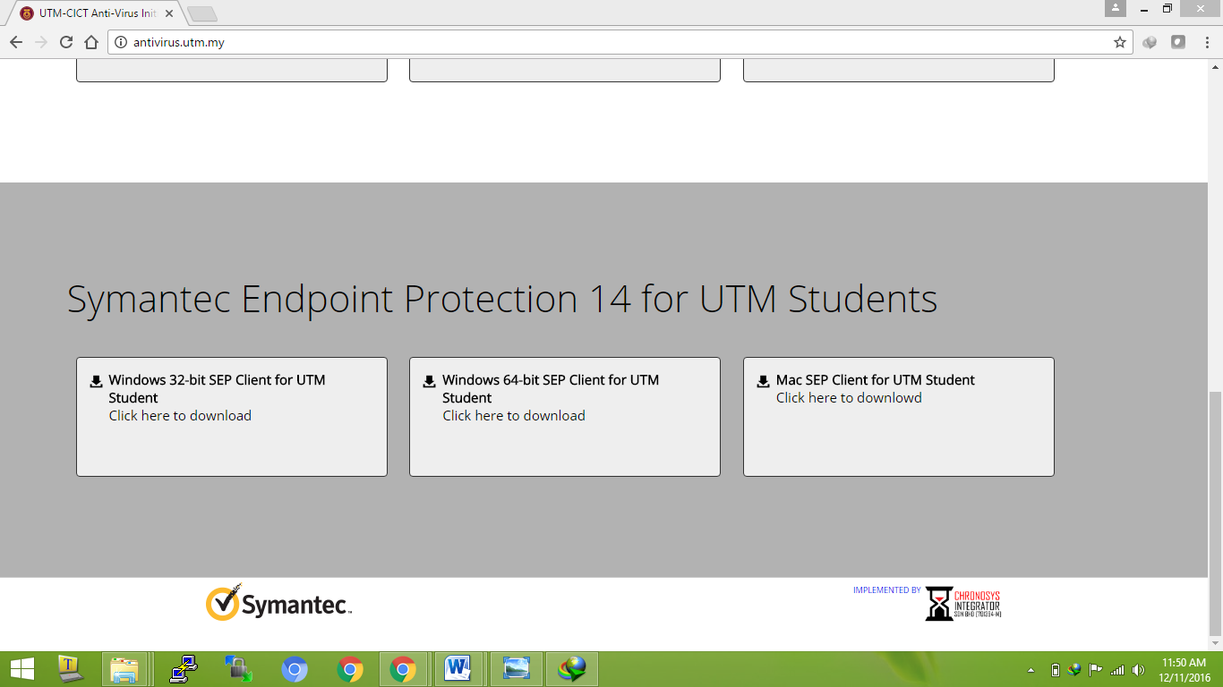
- After Finish download , Open the antivirus software to beginning the Installation.
- Wait until Finish and Click Close.
- Click Restart now, to reboot the system.

