INSTALLING PASW STATISTICS 18

1. Make sure that you have established a BC VPN session successfully.

2. Insert the PASW Statistics 18 Installation Disk into the DVD-ROM Drive.

3. You will then be prompted with the screen below.

Choose the first Option to Install PASW Statistics 18.

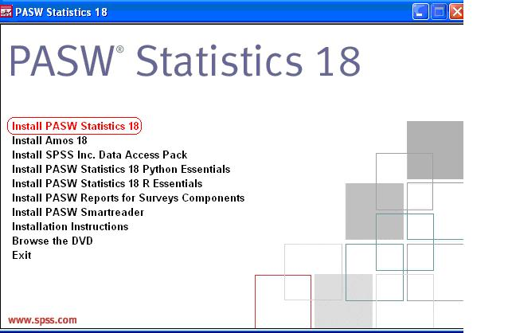

If this screen doesn’t appear automatically, then open the DVD to run the setup.

10
4. Windows will then prepare PASW Statistics 18 to be installed on your pc. You will then see the following screen.

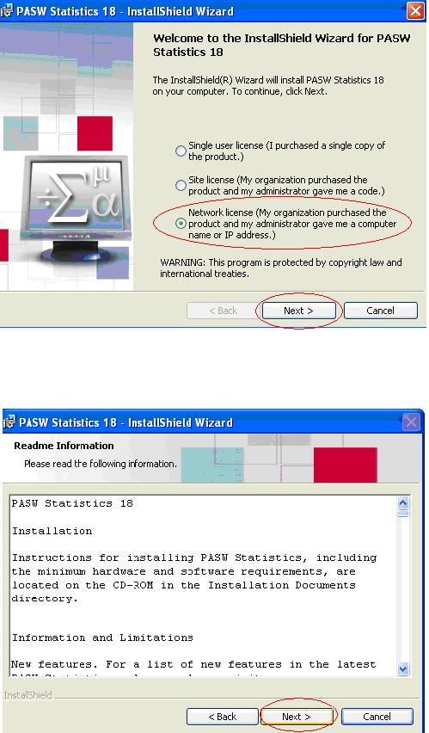

Choose the third option (Network License) and Click Next.

5. Read the Readme File and then click Next.

6. Enter the IP address of the License manager as follows: licenseapp.utm.my

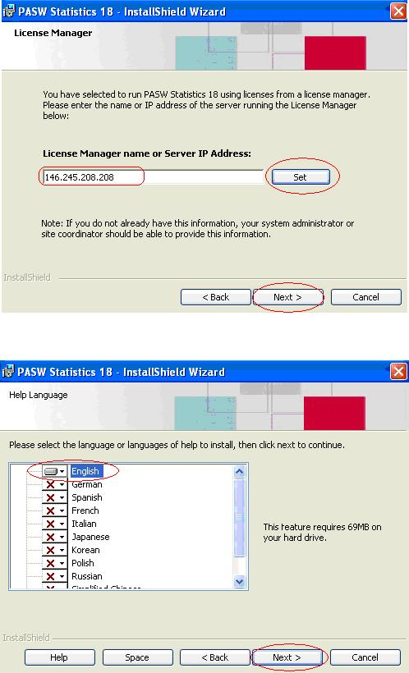
Click Set and then Click Next.

Licenseapp.utm.my

7. Select the language or languages and click Next to continue.

8. Click Next to install the Program to your Computer in the default folder.
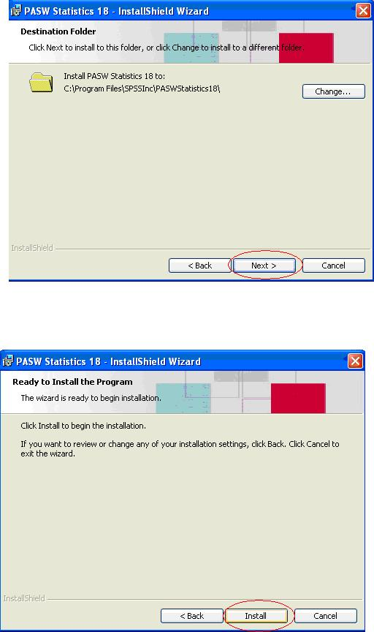

9. Click Install.

10. PASW Statistics 18 will then install itself onto your computer. It will take a few minutes for it to complete.

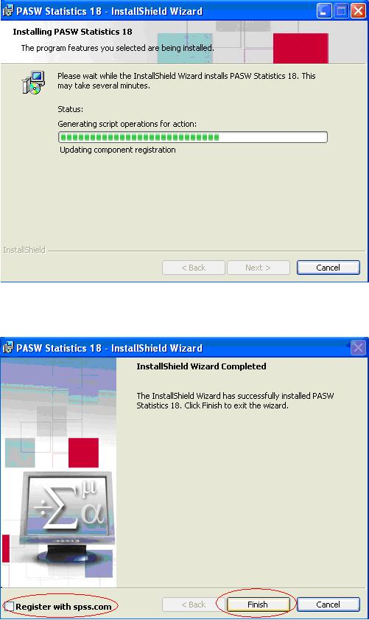

11. When the installation is completed, you will see the following screen.

Uncheck Register with spss.com then click Finish.

14
12. You have finished installing PASW Statistics 18. It is now ready to be used.

13. Remember! If you are accessing PASW Statistics 18 from off campus, you must have an active Internet connection, and you must initiate a VPN session to the college network (see instruction above). After you are done using PASW Statistics 18, please disconnect your VPN session by right-clicking on the VPN icon on your Windows taskbar and choosing DISCONNECT.

15

